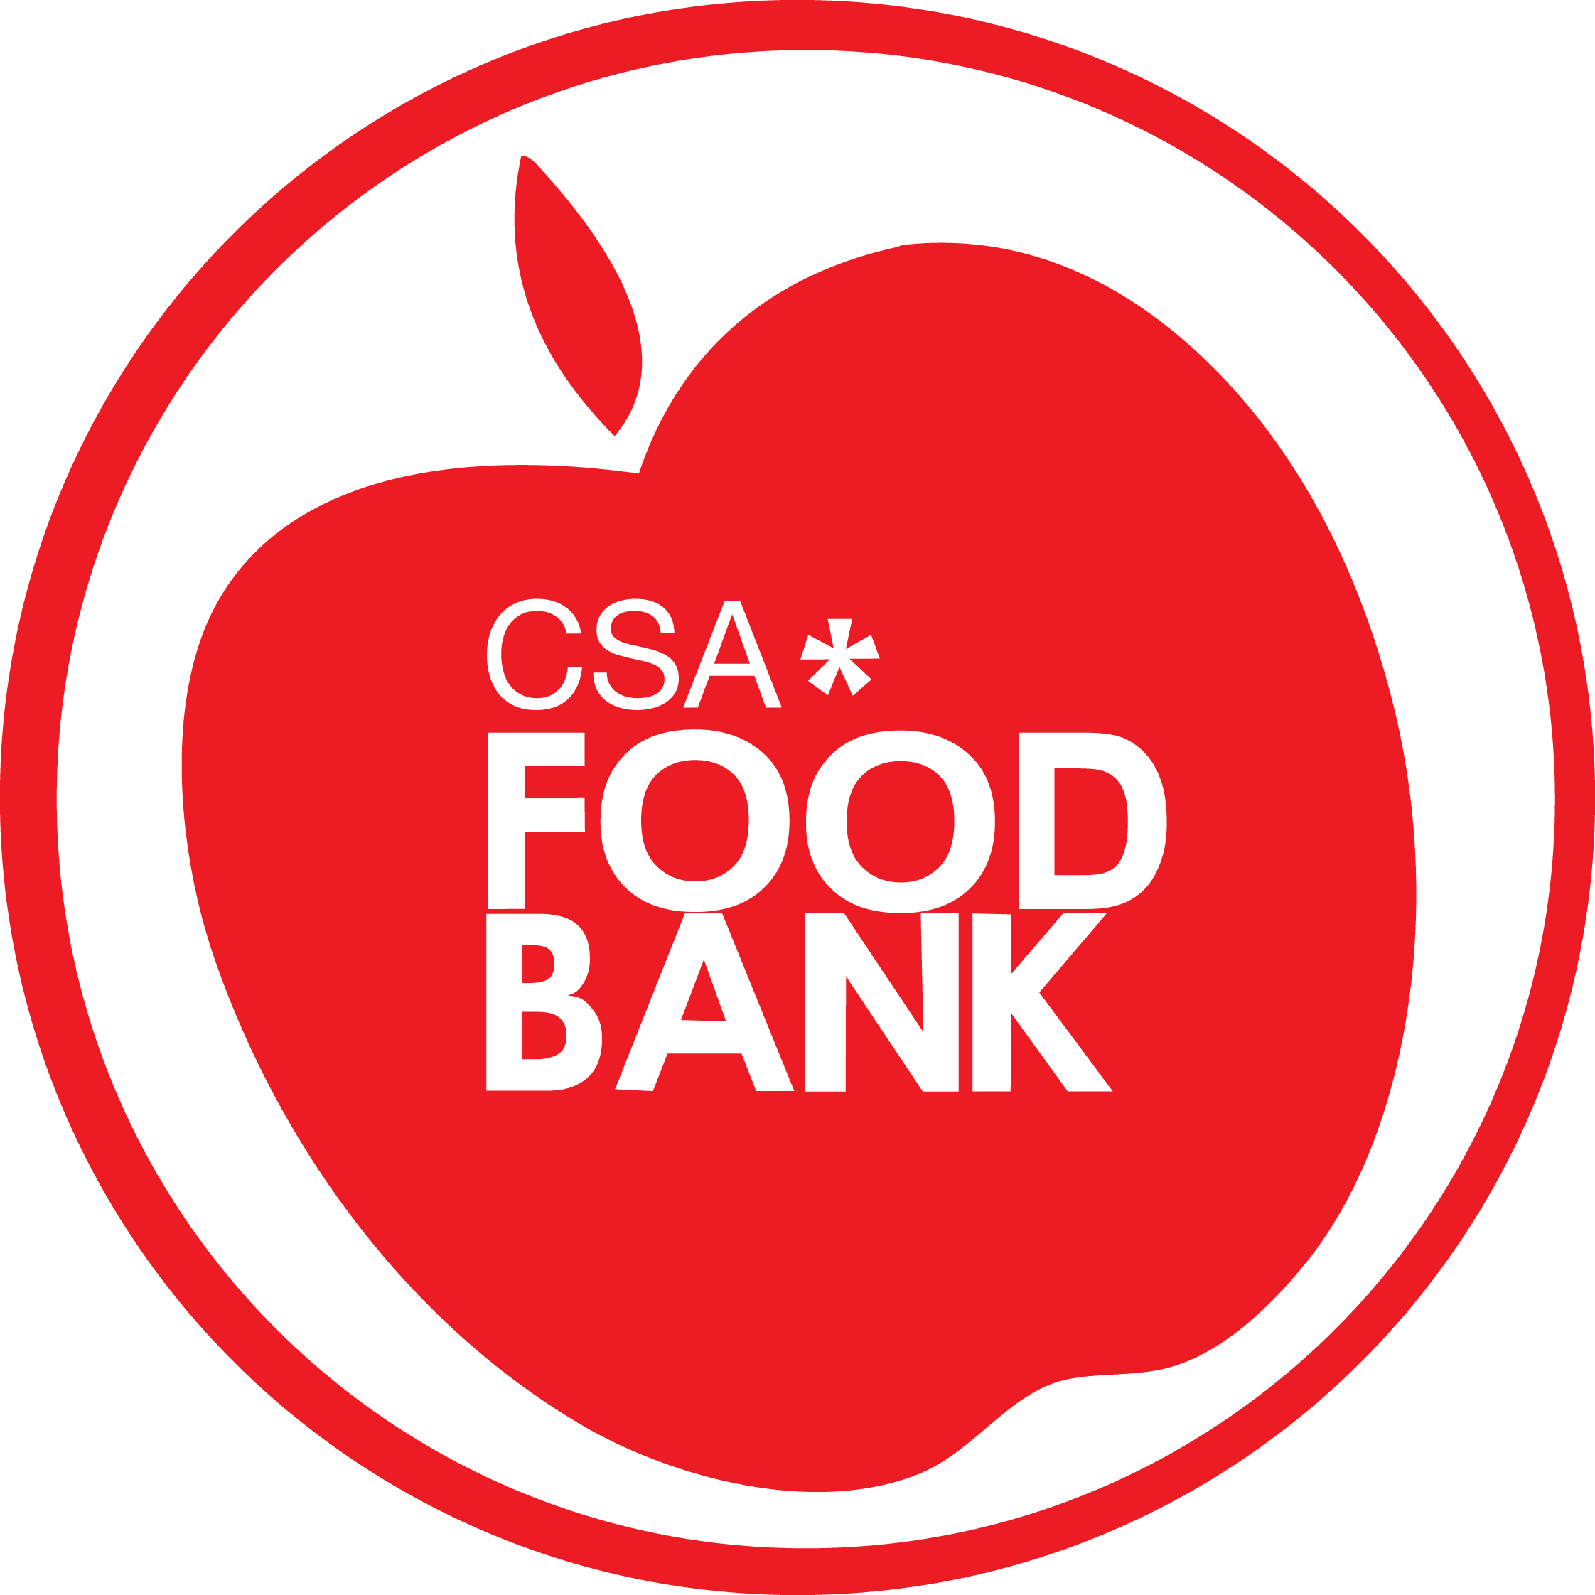
Special Diet Fund Application

This application will be kept confidential by the FoodBank staff.

The Special Diet Fund allows approved students to receive a cash allotment every month to supplement the services they already receive from the FoodBank. This is provided in cases where the student has dietary needs that require them to purchase food that the FoodBank cannot stock or are restricted from fully accessing the available items due to allergies and other health concerns. This funding may also be used to benefit students who need to buy children’s items, such as diapers and baby food.

The student must fill out the entire form. They will be notified within one business day of the status of their application. If approved, the Special Diet Fund is given out monthly, from May-April. They can then set up a regular appointment with the FoodBank Coordinator in order to pick up their funding. Students may only apply for or pick up funding for themselves and must give the Coordinator 24 hours notice prior to pick up. If you are no longer a student, you can only access FoodBank services, including this fund, for up to six (6) months after your graduation date.

Date: ____________________________

Name: _______________________________ Student #: ___ ___ ___ ___ ___ ___ ___ ___

FoodBank Visitor #: ___ ___ ___ ___ Email: ________________________________________@uoguelph.ca

Please list below all dietary restrictions or circumstances that cause your need to be unmet by regular FoodBank service.

__________________________________________________________________________________________________________________________________________________________________________________________________________________________________________________________________________________________________________________________________________________________________
______________________________________________________________________________________________________________________
If there are specific items that would be helpful to you, please list them below so the FoodBank can look into stocking them in the future:

__________________________________________________________________________________________________________________________________________________________________________________________________________________________________________________________________________________________________________________________________________________________________

For FoodBank Office Use:
Application # ________ Visitor ID# ___ ___ ___ ___
Date Received: _______________________ Date Approved: ____________________
Amount to be Issued Monthly: ______ Signature of FoodBank Coordinator: __________________
Notes: _____________________________________________________________________________________________________

