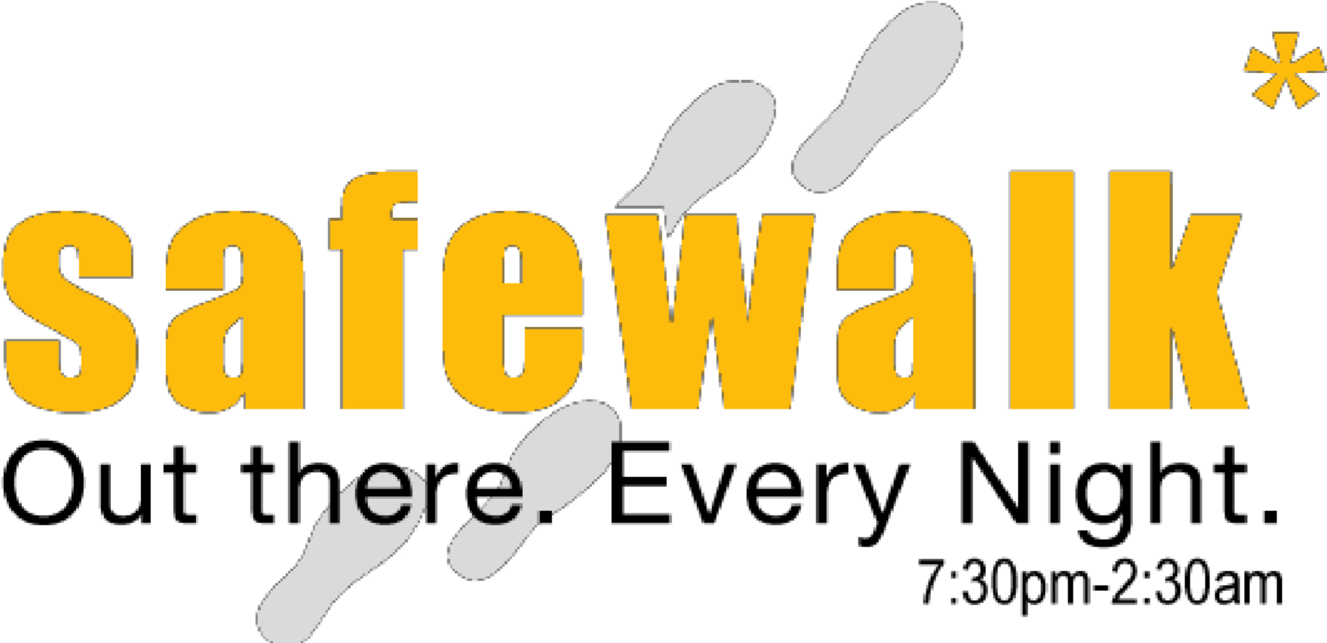
. .</

CSA SAFEWALK APPLICATION 2016-2017

Dear Applicant,

Thank you for your interest in joining the SafeWalk team at the University of Guelph! Each year, we strive to ensure a safe campus environment. As a diverse team of committed student volunteers and leaders, there is never a missed opportunity for team building and skills learning.

Our rewards for our volunteers include a reliable method of transportation home for each late walk shift completed (11:00pm - 2:30am), hospitality beverage coupons for every shift, and monetary gift card prizes throughout the year. In addition, SafeWalk values team building opportunities and plan social events each semester to strengthen our team morale.

With this, I want to add that SafeWalk is fundamentally dependent on the commitment of volunteers. Without them, the safety of our campus would be jeopardized and could lead to potentially preventable situations. By completing this application, you are taking the first step in ensuring your campus is a safe one. We hope that you understand that reliability and commitment is a valued trait that we look for in our team members.

We ask that you answer all questions in this application to the best of your ability. Incomplete applications will not be accepted. Feel free to email safewalk@uoguelph.ca if you have any questions or concerns regarding your application. Please return a hard copy of your completed application form to the SafeWalk Office on the 2nd floor of the University Centre, Room 245 or email an electronic copy to safewalk@uoguelph.ca. Applicants who are accepted will be invited to interview for a volunteer position.
Applications for the F16 semester will not be accepted after Monday, September 19, at 10am.

All the best,

Alex Rozenfeld, Program Coordinator
Simran Arora, Volunteer and Public Relations Coordinator

CSA SAFEWALK APPLICATION 2016-2017

Name:
Student Number:
UoG Email:

Primary Phone Number:
Mailing Address:

Date of Birth:

Emergency Contact:
Relationship to you:
Phone Number:

Program of Study:
Year of Study:

SafeWalk shifts are divided into two shifts a night: early walk (EW) which is from 7:30pm-11:00pm, and late walk (LW) which is from 11:00pm-2:30am. Weekday shifts are considered Sunday, Monday, Tuesday and Wednesday, and Weekend shifts are considered Thursday, Friday, and Saturday. We require volunteers to be available for at least 1 (one) of each. So a volunteer should be available at least one weekday early walk, one weekday late walk, one weekend early walk, and one weekend late walk. Again, this is only “availability”; you will not be scheduled for more than 2 shifts a week.

Do you understand the commitment outlined above? Please enter YES or NO.

Please check or indicate yes for ALL days you are available to volunteer below in the boxes.

 | Mon | Tues | Wed | Thur | Fri | Sat | Sun
Early Walk
Late Walk

How did you hear about Safewalk?

Why do you want to volunteer for SafeWalk?

How would you describe yourself?

What qualities and/or assets do you think an accomplished SafeWalk volunteer should possess?

_________________________________________________________________________________________________

Volunteer Training Day is September 24, from 11:00am to 2:30 pm. Location TBD

Would you be available? YES/NO

Applicant Agreement

I certify that all the above statements made by me in this application are true and I understand that any false or misleading information given by me on this form may result in the rejection of my application or in my dismissal from SafeWalk, should I be accepted as a volunteer.

I acknowledge that failure to properly complete the form will result in the immediate rejection of my application. I acknowledge that failure to attend an individual interview and training will result in the rejection of my application or in my dismissal from SafeWalk, should I be accepted as a volunteer.

I understand that I may be subject to a record check, should I be accepted as a volunteer. Record checks are a matter of routine to ensure that volunteers have no previous criminal records.

I understand that all information obtained in this form will be kept confidential.

By signing this form, you are agreeing that you are aware that SafeWalk’s mandatory training will be on Saturday, September 24th from 11:00am-2:30pm.

Applicant’s Signature Date

Please return completed applications to the SafeWalk Office, Second Floor UC 245, or email an electronic copy to safewalk@uoguelph.ca by Monday, September 19 2016 at 10am.

For Office Use Only

Application: Accepted/Rejected Interview Scheduled Date: ____________________

Interviewer Scheduled: A. Rozenfeld/S. Arora

Signature of Program Coordinator: ________________________ Date: _______________________

